**IronBrand – Understanding Your Total Brand Equity**

**Understanding a brand’s market share is the goal**

Building brand strength in today’s service-oriented world takes a continued focus on those attributes that are most important to the customer. It is no longer good enough to be “just one of the pack”. A brand is an amalgam of thoughts, feelings, associations, experiences, and memories that each person has from previous encounters with the brand.

For that reason, Ironwood Insights Group has established IronBrand Market Tools, a foundation for brand building that reflects all ways consumers interact with choices in today’s market. When attempting to create a brand, building equity becomes even more complicated and challenging. Our ability to evaluate businesses from multiple perspectives allows us to partner more completely with clients to cut through the complexity of brand building by providing clear insights related to positioning, strategy, product development, communications, customer satisfaction, and competitive response.

Brand health includes psychological commitment, or bonding, as well as market factors. Market factors may work in favor or against a brand’s performance in the marketplace.

Our Brand Equity Model is a brand measurement system that combines the measurement of Attitudinal Equity with Market Effects to model a brand’s future growth potential.

The model is built on five metrics:

* Consideration – how many consumers in the market have the brand in their consideration set?
* Share-of-wallet – how many consumers in the market have actually used a specific brand recently?
* Attitudinal Equity – what is the share of desire/brand involvement among consumers in the market?
* Market Effects – which products have barriers that can depress or enhance a brand’s likelihood of being purchased?
* Total Brand Equity – the sum of a brand’s Attitudinal Equity (Share of Desire) adjusted for Market Effects (or Barriers).

Attitudinal Equity: this takes into consideration things like the market environment, competitor activity, marketing communications, personal product experience, word of mouth information. This is the strength of the consumer desire to use a specific brand.

Market Effects: these barriers can include price, distribution network, product availability, gatekeepers, regulation or legislation, product usage memories, and the product range. These are market forces that are preventing consumers from using the brand they would prefer.

Total Brand Equity: the estimated share of the market each brand will receive.

The model is designed to reflect how consumers make decisions.

**Attitudinal Equity Market Effects Total Brand Equity**



+/- =

|  |  |  |
| --- | --- | --- |
| The ability to increase share of brand desire among consumers in the market | The impact that barriers have on a brand’s likelihood of being purchased | The end result of brand desire and market barriers |

Sample IronBrand Output

**Attitudinal Equity Market Effects Total Brand Equity**

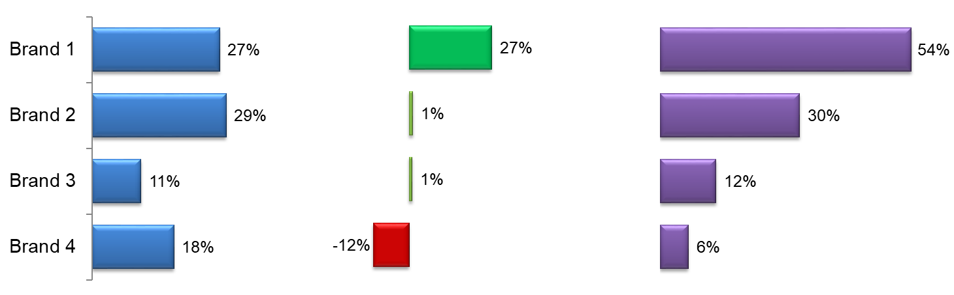

Market effects are physical barriers to product purchase, such as affordability, sold at my store, had a previous bad experience, etc. Brand 1 is clearly benefiting from market effects while Brand 4 is losing share-of-wallet due to market effects.

How IronBrand can help you.

* Identify the market effects that influence your brand share-of-wallet.
* Good management of market effects can help you to pull market share from competitors.
* Help you to understand which competitors are the biggest risk to your brands and why.

Why is IronBrand a better approach?

* We provide you with information that directly relates to your business outcomes. Knowing what market barriers your product faces can help you implement strategies that can improve your share-of-wallet and real returns.
* The competitive set in your market is defined by the respondent. The consideration questions identify brands that are of interest.
* Attitudinal equity is calculated at the respondent level. We can help you to understand those market segments where your brand is strong and weak.
* Understanding this information can help senior management to implement strategies that can increase attitudinal equity and reduce market effects.